

National Textile University

**Department of Computer Science**

Subject:

Operating System

Submitted to:

Sir Nasir

Submitted by:

Asbah Asif

Reg number:

23-NTU-CS-1141

Lab no: 04

Semester: 5th

**3. C Programs with Threads Program 1:**

**Creating a Simple Thread**

**Task 1:**

**Code:**

#include <stdio.h>

#include <pthread.h>

#include <unistd.h>

// Thread function - this will run in the new thread

void* thread_function(void* arg)

 {

printf("Hello from the new thread!\n");

printf("Thread ID: %lu\n", pthread_self());

return NULL;

}

int main()

{

pthread_t thread_id;

printf("Main thread starting...\n");

printf("Main Thread ID: %lu\n", pthread_self());

// Create a new thread

pthread_create(&thread_id, NULL, thread_function, NULL);

// Wait for the thread to finish

pthread_join(thread_id, NULL);

printf("Main thread exiting...\n");

return 0;

}

**Output:**

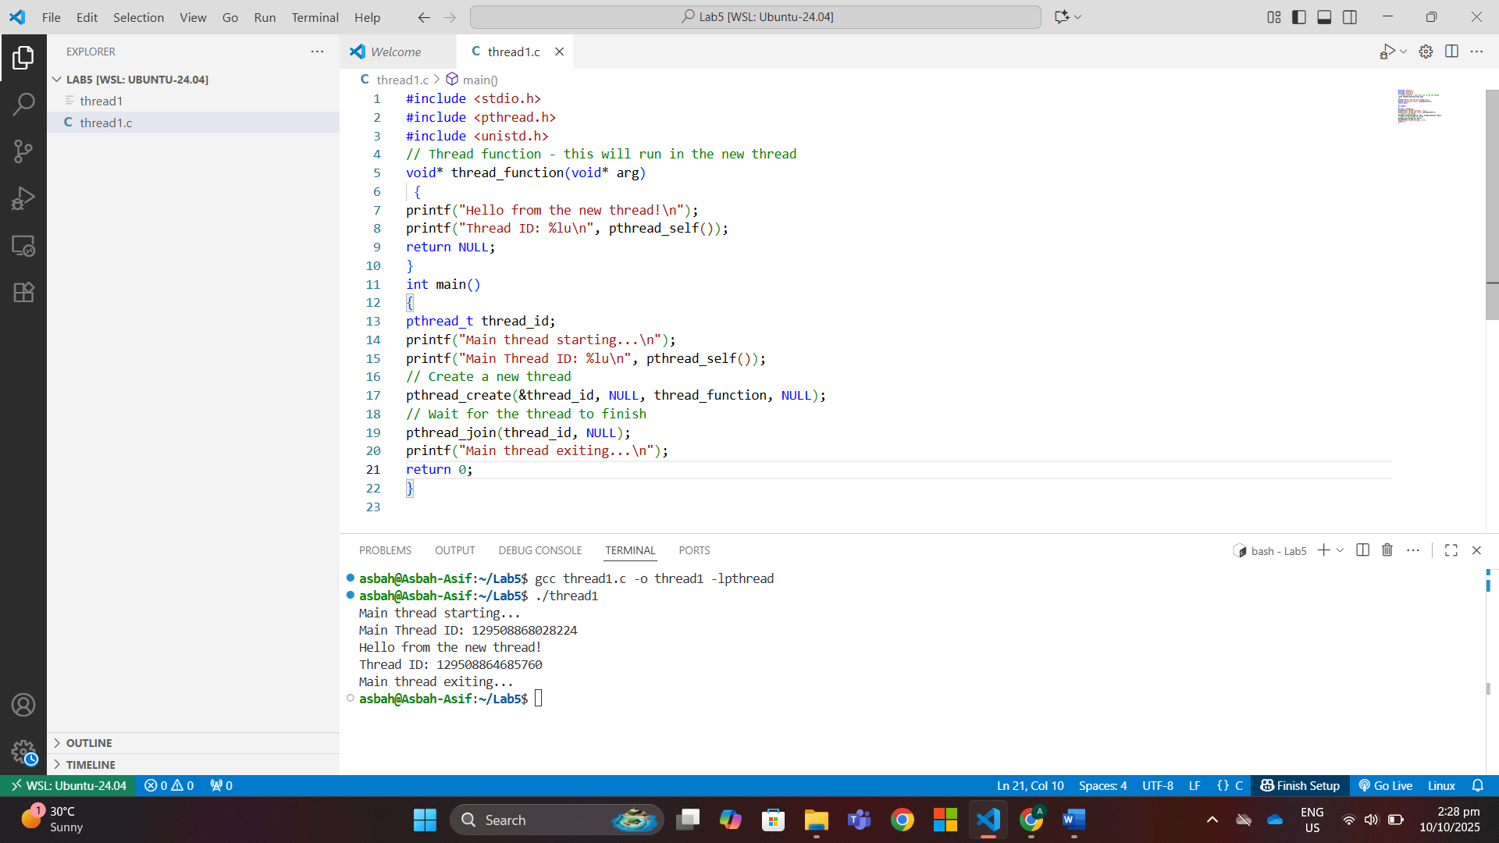

**Program 2: Passing Arguments to Threads**

**Code:**

#include <stdio.h>

#include <pthread.h>

void* print_number(void* arg) {

    // We know that we've passed an integer pointer

int num = *(int*)arg; // Cast void* back to int*

printf("Thread received number: %d\n", num);

printf("Square: %d\n", num * num);

return NULL;

}

int main() {

pthread_t thread_id;

int number = 42;

printf("Creating thread with argument: %d\n", number);

// Pass address of 'number' to thread

pthread_create(&thread_id, NULL, print_number, &number);

pthread_join(thread_id, NULL);

printf("Main thread done.\n");

return 0;

}

**Output:**

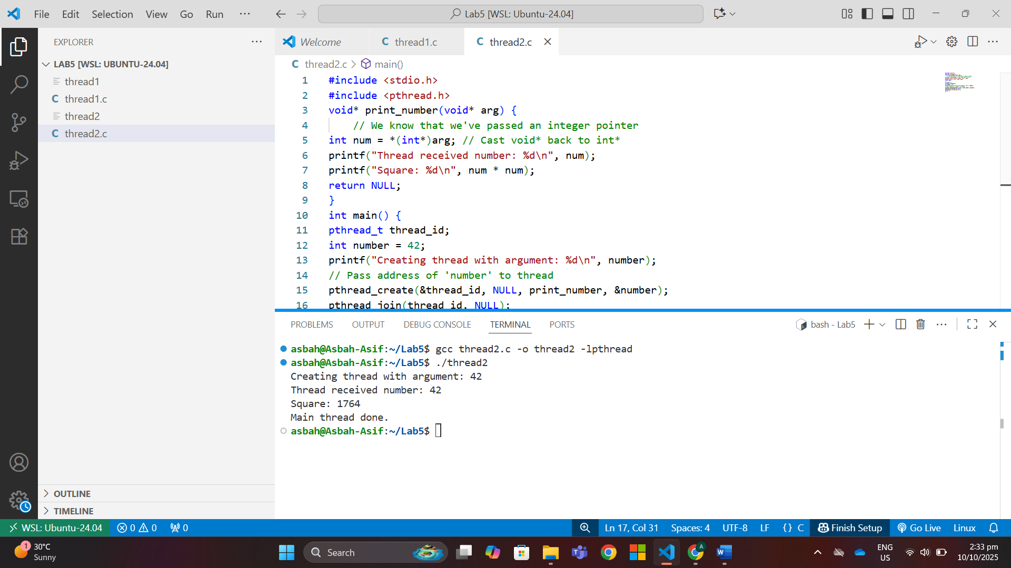

**Program 3: Passing Multiple Data**

**Code:**#include <stdio.h>

#include <pthread.h>

typedef struct {

int id;

char* message;

} ThreadData;

void* printData(void* arg) {

ThreadData* data = (ThreadData*)arg;

printf("Thread %d says: %s\n", data->id, data->message);

return NULL;

}

int main() {

pthread_t t1, t2;

ThreadData data1 = {1, "Hello"};

ThreadData data2 = {2, "World"};

pthread_create(&t1, NULL, printData, &data1);

pthread_create(&t2, NULL, printData, &data2);

pthread_join(t1, NULL);

pthread_join(t2, NULL);

printf("All threads done.\n");

return 0;

}

**Output:**

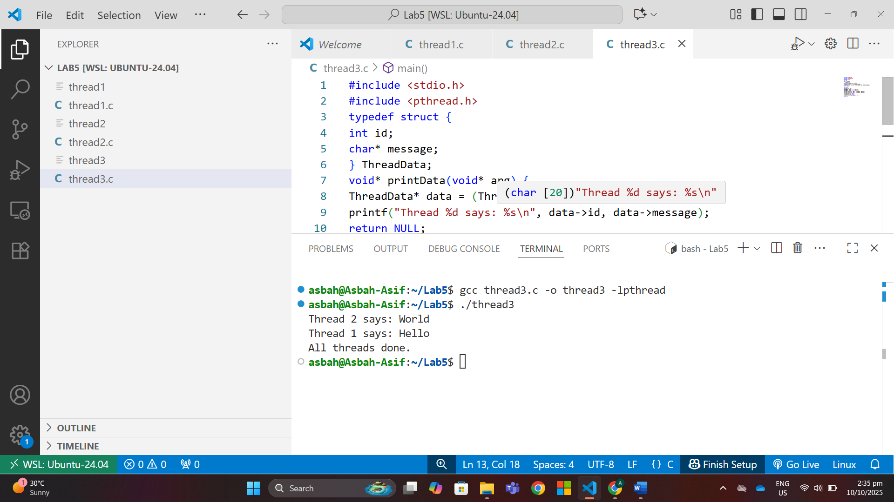

**Program 4: Multiple Threads**

**Code:**

#include <stdio.h>

#include <pthread.h>

#include <unistd.h>

void* worker_thread(void* arg) {

int thread_num = *(int*)arg;

printf("Thread %d: Starting work...\n", thread_num);

sleep(1); // Simulate some work

printf("Thread %d: Work completed!\n", thread_num);

return NULL;

}

int main() {

pthread_t threads[5];

int thread_args[5];

// Create 5 threads

for (int i = 0; i < 5; i++) {

thread_args[i] = i + 1;

printf("Main: Creating thread %d\n", i + 1);

pthread_create(&threads[i], NULL, worker_thread, &thread_args[i]);

}

// Wait for all threads to complete

for (int i = 0; i < 5; i++) {

pthread_join(threads[i], NULL);

printf("Main: Thread %d has finished\n", i + 1);

}

printf("All threads completed!\n");

return 0;

}

**Output:**

**Program 5: Thread Return Values**

**Code:**

#include <stdio.h>

#include <pthread.h>

#include <unistd.h>

// Thread function - this will run in the new thread

void* thread_function(void* arg)

 {

printf("Hello from the new thread!\n");

printf("Thread ID: %lu\n", pthread_self());

return NULL;

}

int main()

{

pthread_t thread_id;

printf("Main thread starting...\n");

printf("Main Thread ID: %lu\n", pthread_self());

// Create a new thread

pthread_create(&thread_id, NULL, thread_function, NULL);

// Wait for the thread to finish

pthread_join(thread_id, NULL);

printf("Main thread exiting...\n");

return 0;

}

**Output:  
